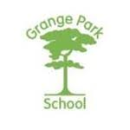
Grange Park School
Borough Green Road
Wrotham
Kent
TN15 7RD

The step up from Key Stage 4 to Key Stage 5 (Post 16) is a significant one and it is really important that both you and your child fully understand what the options are at Grange Park school: All students continue to receive the same tailored support offered by Grange Park regardless of location.

Pathway 1: Post16 full time at Grange Park School (Wrotham)

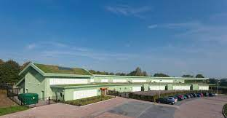
For pupils not yet ready to access the other pathways, Grange Park provide a curriculum at the Wrotham Site, aimed at progressing students into College. The pupil remains a student at Grange Park School for the duration of their study and will attend lessons Monday to Friday at the Wrotham site and be supported in lessons in much the same way as Bower Grove.

Pathway 2: Post 16 at College (College Partnership Mid-Kent)

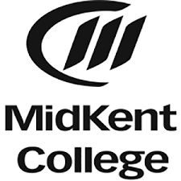
The student will attend a chosen course at Medway or Maidstone college and will need to apply for their choice of subject independently.
There is a Grange Park Hub in the college where students can take time out, work on life skills and access the support of Grange Park Staff.
The Student will be supported in interviews, exams and lessons in Mid Kent College by Grange Park staff.
Students will be encouraged at a suitable time to transition into college independently of Grange Park.

For further information please contact the school directly.

Telephone 01732 882111

Email office@grangepark.kent.sch.uk

Website: grange-park-school-kent.co.uk

