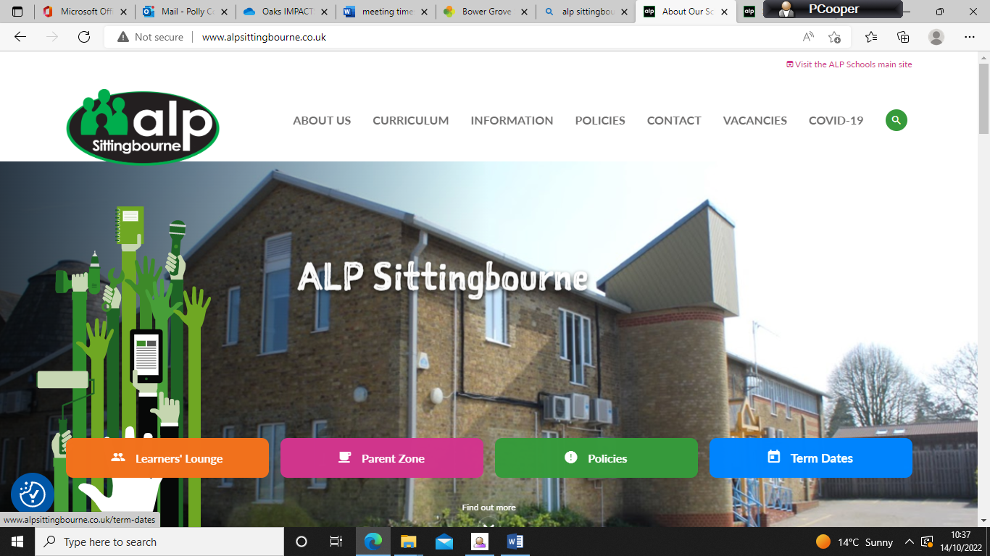

Empowering Success Through Holistic and Individualised Learning
ALP Schools are a chain of Independent Special Needs Schools. Each of our schools is Ofsted registered and cater for young people who have struggled in mainstream education due to their special educational needs.
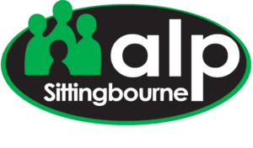
Our unique selling point is that we offer small classes or one to one learning where the curriculum is tailored to the needs of the individual. We also recognise the importance of building routines, relationships, respect and trust in order to achieve successful teaching and learning…
Contact details
Head Teacher – Jenny Thomason
01795701102
jenny.thomason@alpschools.org
General Enquiries – Sittingbourne@alpschools.org
ALP Sittingbourne 60 Bell Road Sittingbourne ME10 4HE
Website - www.alpsittingbourne.co.uk


