Dear Parents,

Bower Grove School has a visit from author Jane Elson on Wednesday 1st March as part of the World Book Day celebrations.

Jane Elson is a multi-award-winning author whose won over twelve literary awards for her writing, and twice been nominated for the prestigious Carnegie Medal. Her debut novel A Room Full of Chocolate was longlisted for the Branford Boase Award. When Jane is not writing, she is an advocate for many charities close to her heart, including All Dogs Matter – whose dog shows she has lots of fun judging! Jane is loud and proud about her dyslexia and when not writing likes to mentor neurodivergent young people and promote the gift of alternative thinking. In 2019, Women Beyond The Box honoured her as one of the Top 50 Influential Neurodivergent Women.

Jane’s book Moon Dog published in August 2020 has since gone on to win the Cumbria SLS Primary Spellbinding Book Award, the Inspire Book Award and was awarded The Barkers’s Book Award for Dogs in Literature, judged by BBC Barking Hour’s Anna Webb. Her latest book Storm Horse is dyslexic friendly and has a dyslexic protagonist.

If your child would like to order a book for Jane Elson to sign and dedicate to your child, please use the form below.

More information about Jane’s books:
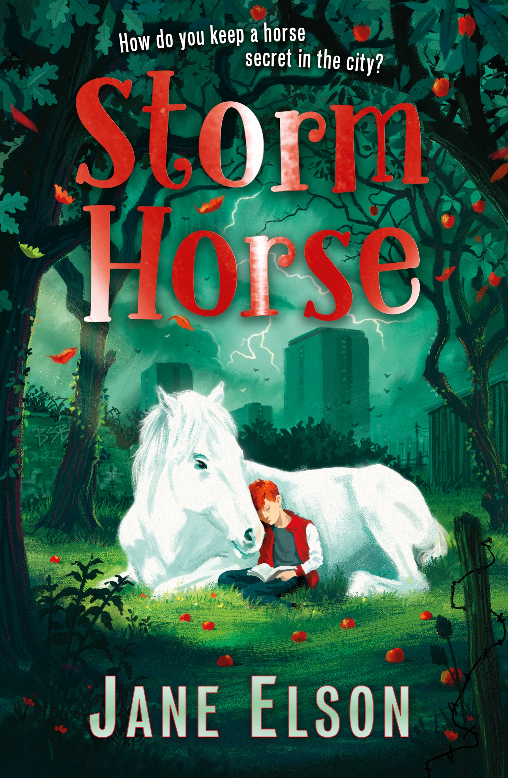
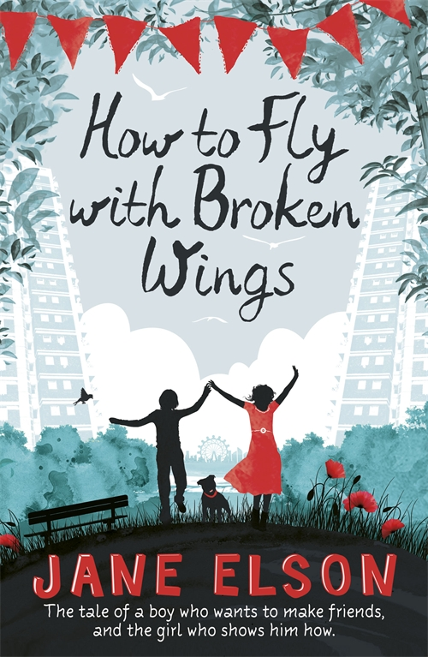
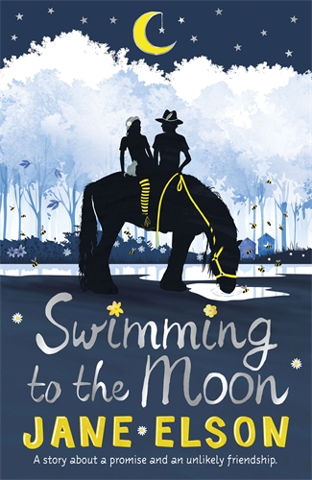
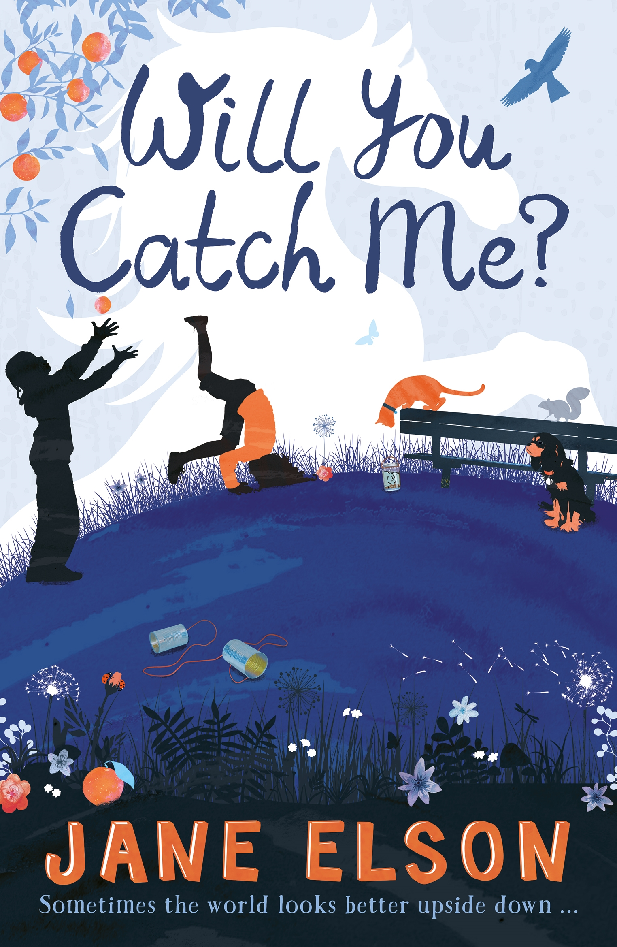
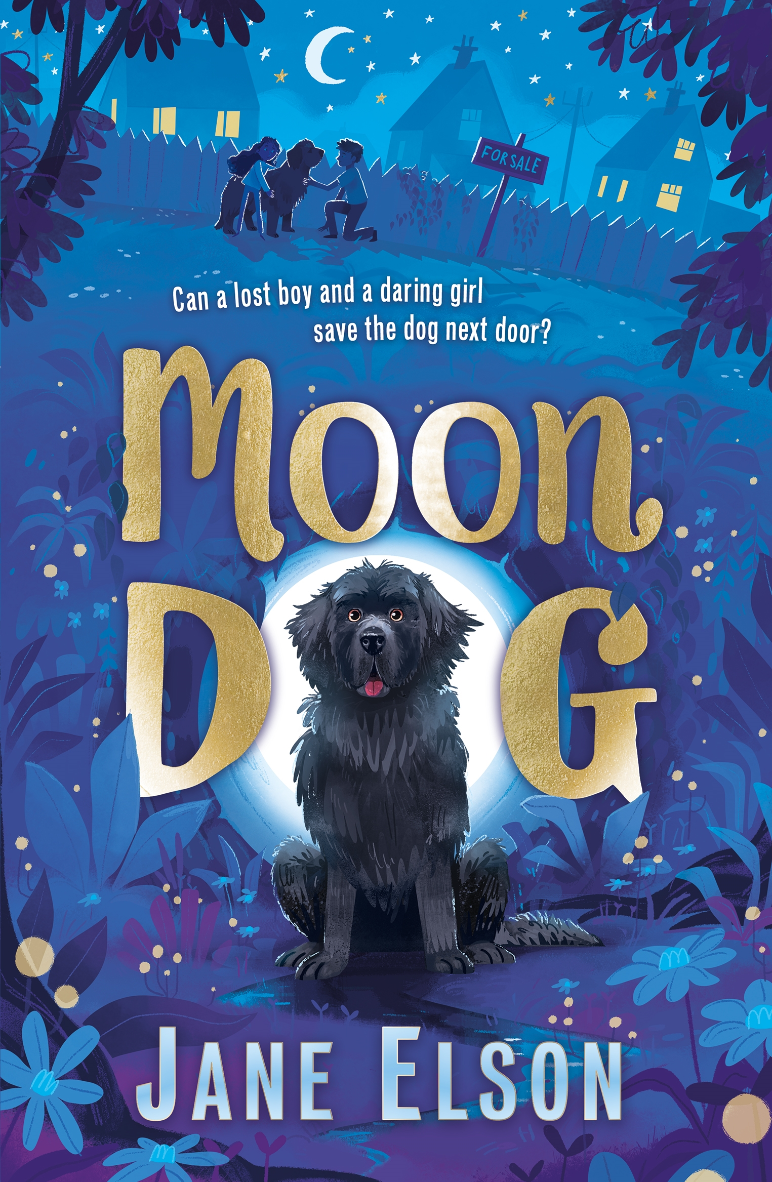
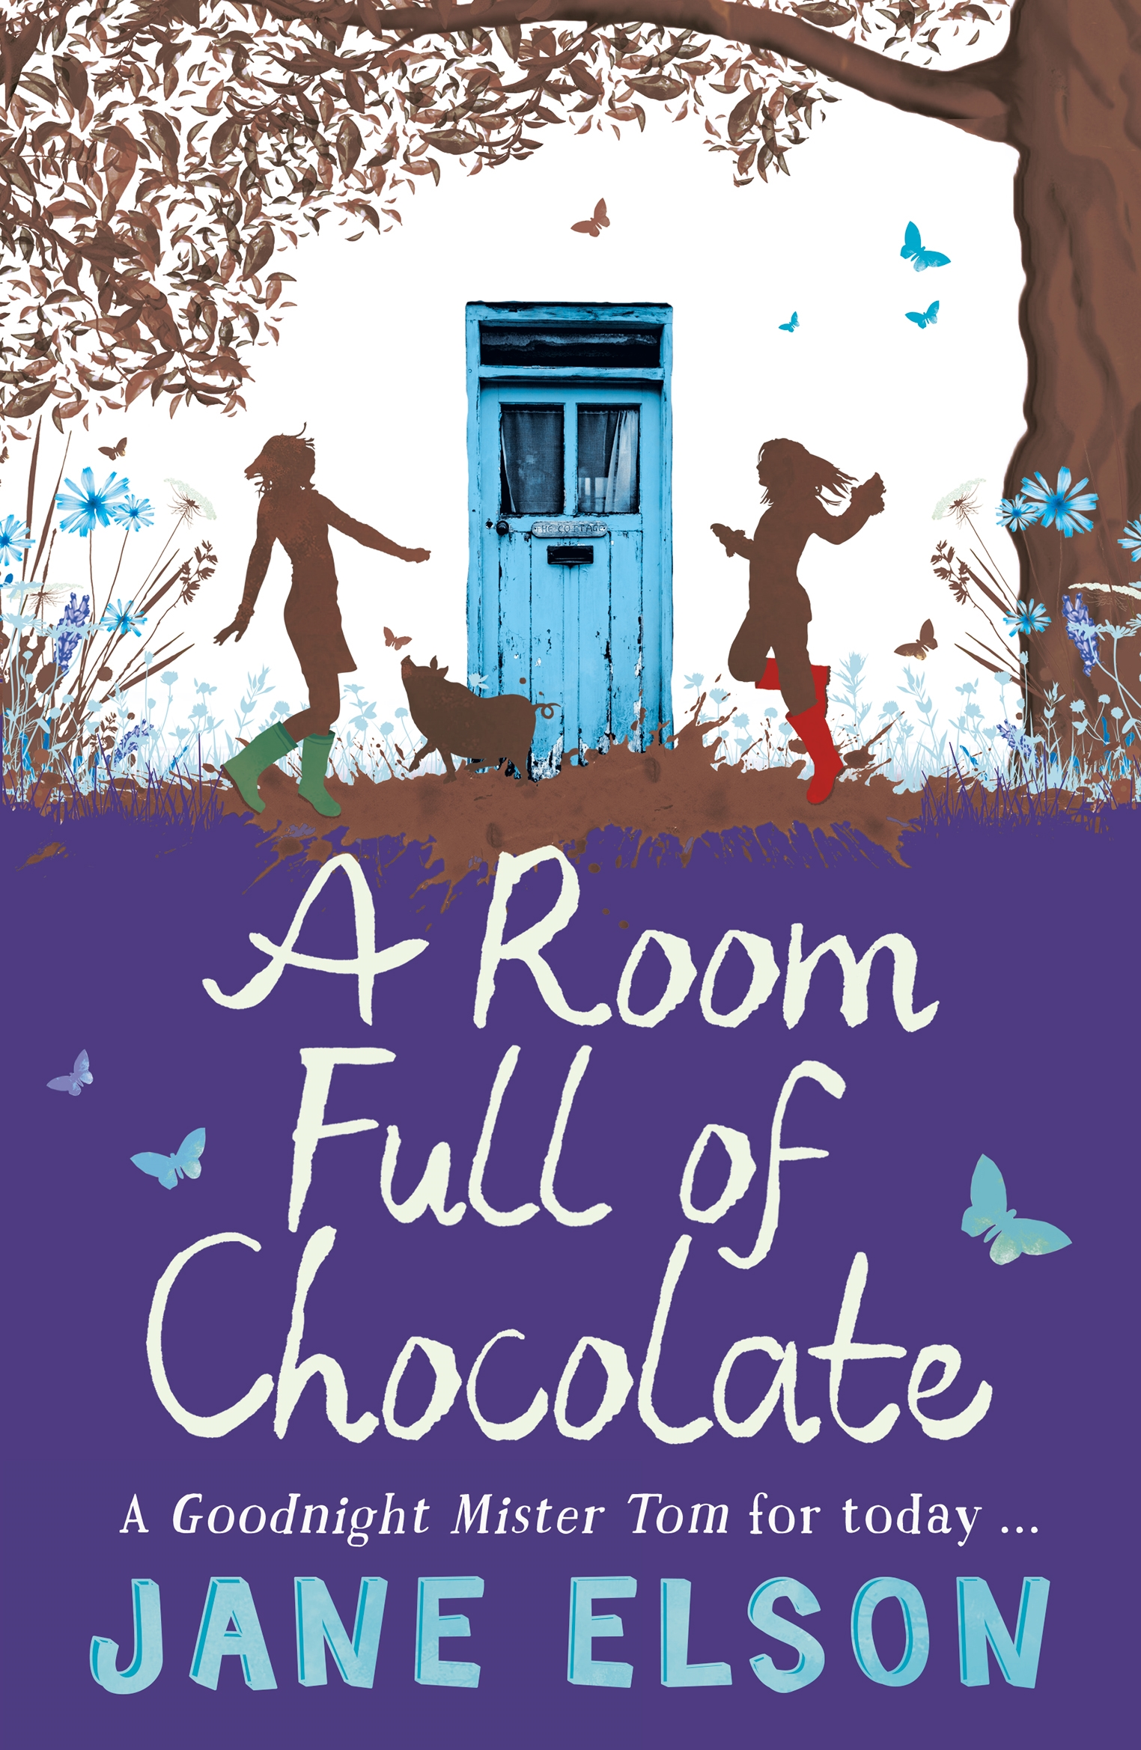

Storm Horse*

For Daniel Margate, life is muddled because everything moves: letters, numbers, even classrooms sometimes. Daniel is dyslexic and most of the time, school just doesn't make sense. He's in the bottom reading group at school with other kids who are trying to make sense of it all. There's Akin who can't sit still for more than two minutes and is almost always getting into trouble, sports star Ste is recovering from a car accident that left him learning how to walk again and Molly-May who just wants to fit in. But when a mystery horse gallops into their lives one stormy evening, it changes everything.

Desperate to keep him safe they form the Secret Horse Society and vow to protect this amazing creature. Inspired by stories of the great racehorse Seabiscuit, they name him Jammie Dodger and find they when they work together, nothing seems impossible. They just need to keep their new horse friend a secret. How hard can it be to hide a horse, anyway?

Moon Dog

Marcus and Delilah couldn't be more different. He is as big as she is tiny. As angry and lost as she is tremendous and brave. But they share a dream: to own a dog of their own.

So when a mystery pup turns up in the empty house next door, Marcus can't believe his luck. He visits him every night and names him Moon Dog.

But it's soon clear that Moon Dog is in danger, and when Marcus and Delilah discover a dark secret it will test their bravery and their friendship.

Can they work together to save their dream dog?

‘A beautiful, captivating story of friendship, of overcoming hurdles, of being true to yourself, funny, honest, true, and authentic: a powerful warm book to love and treasure’ The School Librarian

A Room Full of Chocolate

Grace's fun-loving mum has found a lump. Her north London world of sleepovers, tap dancing and playing the clarinet fall apart when she is sent to live with her grumpy old granddad on his farm in Yorkshire while her mother goes into hospital to get better.

Grace misses her mother so much it hurts, and doesn't quite understand what is happening to her. And things go from bad to worse when she starts school and becomes the bullies' latest target.

But Grace is no longer alone when she meets Rainbow Girl Megan and her pig, Claude -when she's with them she feels as if she can confront anything. At Easter time when Grace misses her mum the most, she knows she must find a way to get to London. With Megan's help, she hatches a plan to run away that involves Claude, chocolate Easter eggs and a risky ID swap. But it's all worth it if it means that she finally gets to see her mum.

‘Full of emotion and humour... I couldn't put this book down!’ Guardian

How to Fly with Broken Wings

Twelve-year-old Willem has two main aims in life: to fly and to make at least two friends of his own age. But all the other boys from the Beckham Estate do is make him jump off things. First his desk – and now the wall. As his toes teeter on the edge, Sasha Bradley gives him a tiny little wink.

Bullied by Finn and his gang the Beckham Estate Boyz, Willem has no choice but to jump. As he flies through the air he flaps his arms, wishing he could fly and escape into the clouds. Instead he comes crashing down and breaks his ankle.

Sasha, angry with herself for not stopping Finn and his Boyz, is determined to put things right. And soon, while the gangs riot on their estate, Willem and Sasha form an unlikely friendship. Because they share a secret. Sasha longs to fly too.

‘Heart-rending, heart-breaking and heartening’ The Best New Children's Books 2015 Guardian Supplement

Swimming to the Moon

Bee stumbles through life in her stripy socks with her head in the clouds, doing her very best to keep out of the way of her bickering parents and avoid bendy tap dancing Crystal Kelly – who makes her life a misery. But when Crystal double-dares her to volunteer for a sponsored swim in honour of her great grandmother Beatrix's memory, Bee can't back down. Even though she is terrified of water and cannot swim!

Then new boy Moon-Star gallops to Bee's rescue on his horse and takes her to meet Old Alice, who lives in a beautiful painted wagon. As Bee enters this new world, her life is changed for ever.

Finally, she has an ally. Down by the promise tree the new friends make a pact – Moon Star will teach Bee to swim if Bee will teach him to read. They spit on their hands and shake on their vow and a beautiful friendship begins.

‘Fans of Jacqueline Wilson and Elen Caldecott will like this real-world drama ... Warm and dreamy with just the right amount of quirk for young readers to identify with if they feel like outsiders.’ Booktrust

Will You Catch Me?

Nell Hobs lives with a tortoise called Bob Marley, guinea pigs Asbo and Chaos, goldfish Beyoncé and Destiny, gerbils Fizz and Tyrone, Aunty Lou the Hamster ... and her mum, who drinks too much. Nell does everything she can to be a good daughter so that her mum will stop. But when things get really hard, Nell stands on her head. Everything looks better upside down, don't you know?

Nell wishes she knew who her dad was. When new teacher Mr Samuels tells the class the story of Nell Gwynn, the Orange Girl who became one of the first actresses on the London stage, Nell is captivated and is determined to dress up as an Orange Girl for the Costume Parade. She hatches a plan with her best friend Michael: a way to make her dad step forward and claim her. Will she succeed?

'A heart-warming story about identity and courage, and a tremendous young girl ... For fans of Jacqueline Wilson and Sarah Lean.' Lovereading4kids

Child’s name and class …………………………………………………………………………………………………….

Number of books (at £6.99 each – please specify which book/s)
……………………………………………………………………………………………………………………………………………………………...............................................................................................................................................................................................................................................................................................................................................................................................................................................................................................................................................

Dedication inside the book (e.g. To Chloe) ………………………………………………………………………

Parent’s signature……………………………………………………………………………………………………………

